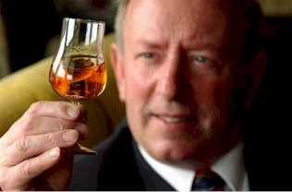
We’ll tak’ a cup o’ kindness yet – the Story of Scotch Whisky

David Wishart

University of St Andrews

The 60th LHCb Collaboration Week, University of Edinburgh
18.00 Tuesday June 28th, 2011

Discover the flavours of Scotch, Irish and Welsh malt whiskies at this talk and tasting by Dr. David Wishart, Fellow of Management at the University of St Andrews and author of Whisky Classified: Choosing Single Malts by Flavour.
Dubbed the "Carl Linnæus" of whisky by fellow writer Charles MacLean, David Wishart was the first to categorize single malt whiskies by flavour. He will guide you through the history and romance of Scotch whisky, from the aqua vitae of the early monasteries, the alchemist's quest for an elixir of eternal life, and the hedonistic uisge beatha of remote Scottish crofts, the monopoly of the surgeon-barbers, smuggling into the Royal Mile taverns, and hot toddies in Edinburgh's New Town.
Whisky is evoked in the poetry of Burns, in the travelogues of Stevenson, and in the art of Landseer and Wilkie. London toasted with brandy in the Regency period, but when a tiny phylloxera beetle devastated Cognac after 1863 the upper classes turned to whisky and the famous “Scotch” brands were born.
Today, the flavour of malt whisky is more diverse than ever, due to the influence of variable peating, cask preparation, extended maturation, and special finishing. David describes his unique scientific classification by flavour based on sensory analysis and profiling, with a selection of fine single malt whiskies to taste.
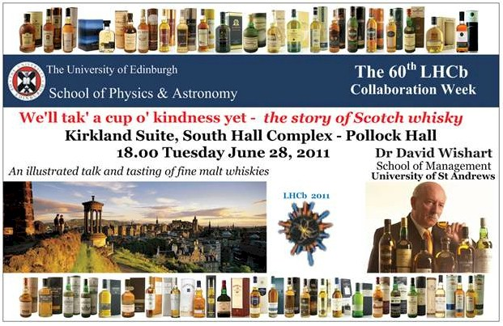
He has chosen some well-known favourites for his tasting, plus a couple of malts that are harder to find. They span the "malt spectrum", the complete range of flavours of single malt whiskies as described in David's book "Whisky Classified". For tonight's tasting he will present a selection of Aberfeldy, Aberlour, anCnoc, Balblair, Balvenie, Ben Nevis, Benromach, Bunnahabhain, Connemara, Deanston, Dufftown, Glencadam, Glenfarclas, Glenfiddich, Glengoyne, Glenlivet, Glenrothes, Green Spot, Glenturret, Highland Park, Laphroaig, Ledaig, Longmorn, Macallan, Old Pulteney, Penderyn, Redbreast, Royal Lochnagar, Scapa, Smokehead, Speyburn, Talisker, Tobermory, Tomintoul, Tullibardine and Tyrconnell single malt whiskies.
Further information at: www.whiskyclassified.com

